This article has been designed as a template. Please make sure to update or change the highlighted text in the article with information pertinent to your company.

High Efficiency Residential Gas Dryers
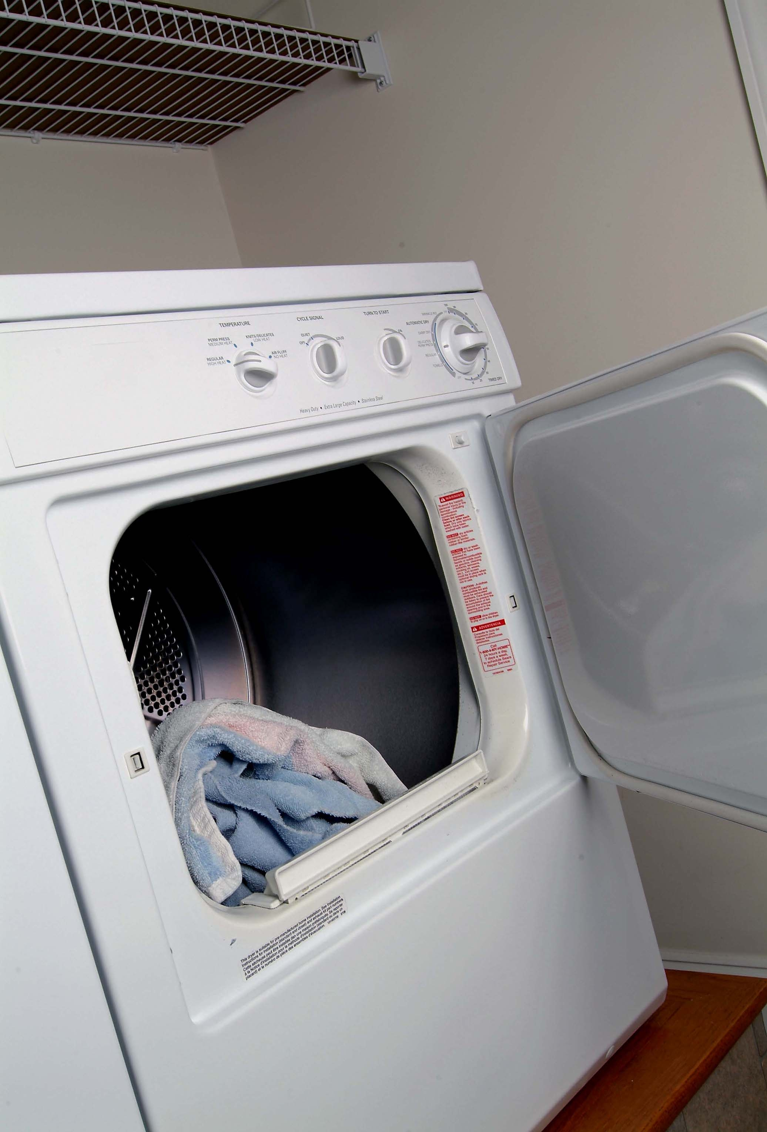
When it comes to appliances, the clothes dryer is typically the second-largest energy user in the home, right after the refrigerator. Most homeowners spend about $85 a year to operate their clothes dryer and can expect to spend approximately $1,530 over the course of the dryer’s 18-year expected lifetime. There are steps you can take to minimize your dryer’s energy use and save your household money.

Gas Vs. Electric Dryers
Natural gas models offer faster drying times and require less money to operate than their electric counterparts. On average, the electric energy needed to dry a typical load of laundry costs 30 to 40 cents, compared to natural gas, which costs only 15 to 20 cents. A high efficiency natural gas dryer may cost more upfront, but it will save you money in the long run. Additionally, using natural gas appliances can help reduce greenhouse gases and global warming. Most of our electricity is generated by burning coal, which produces 45 percent more carbon dioxide than natural gas. Because of this, our homes generate even more pollution than the cars we drive.

What to Consider When Buying a New Dryer
- Check the efficiency numbers when comparing models, but keep in mind that you won’t find EnergyGuide or ENERGY STAR® labels on the units. Since clothes dryers don’t vary widely in efficiency, they aren’t required to have an EnergyGuide label and don’t qualify for ENERGY STAR® labeling. As is the case with many energy efficient appliances, a slightly higher upfront cost for a more efficient model can save you money in the long term.
- Purchase a model with a moisture sensor. When the clothes are dry, the machine shuts off rather than continuing to run until the time is up. Most units only estimate dryness through the temperature of the exhaust air, but a very efficient dryer will have a moisture sensor in the drum. A temperature-sensing control can save you about 10 percent compared to timed drying, whereas a moisture sensor can save about 15 percent. You not only conserve money and energy, you also avoid additional wear and tear on your clothes because they won’t be overdried.
- Look for a model that has a cool-down or perma-press period. These cycles use cool air and tumble dry in the last few minutes of the drying process, rather than continuing to use heat.

More Energy Saving Tips
- Run full loads and you’ll spend less money per item of clothing. .
- Empty the lint trap between loads. This will make the drying cycle more efficient.
- Put your dryer in a heated space in the home. Storing it in a cold basement or garage will only mean it has to work harder.
- Periodically check your dryer’s outside exhaust vent. If it doesn’t close tightly, replace it with one that will prevent outside air from leaking in.
- Vent properly. When venting exhaust to the outside, use the straightest and shortest metal duct available. Flexible vinyl ducting isn't recommended because it restricts the airflow, can be crushed and may not withstand high temperatures from the dryer.
- Dry similar fabrics together. Lighter synthetics require less drying time than natural fibers and heavier items, such as bath towels.

Residential Natural Gas Dryer Manufacturers
- Rinnai www.rinnai.us
- Kenmore www.kenmore.com
- Whirlpool www.whirlpool.com
- GE www.ge.com
- Amana www.amana.com

Additional Residential Natural Gas Dryer Resources
- Energy Solutions Center www.energysolutionscenter.org
- National Fuel www.natfuel.com
- California Energy Commission www.consumerenergycenter.org
- Questar Gas www.thermwise.com
- U.S. Department of Energy www.doe.gov

For information on rebates and tax credits available for residential gas dryers, visit our website:

www.consumerenergycenter.org
www.consumerenergycenter.org
www.consumerenergycenter.org

