This article has been designed as a template. Please make sure to update or change the highlighted text in the article with information pertinent to your company.

High Efficiency Residential Pool Heaters
Natural gas swimming pool heaters are the most popular way to heat pools. They’re ideal for heating swimming pools quickly and, unlike solar or heat pump units, they can be used in any type of climate or weather. Additionally, natural gas is considered the cleanest fossil fuel and is abundant throughout North America, making it the better choice for the environment.

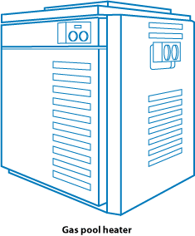
Swimming pools are very large consumers of energy, primarily because much of the heat is lost through evaporation. An average pool loses one to one-and-a-half inches of water a week through evaporation—taking with it the energy that heated the water. All told, evaporation accounts for 70 percent of a swimming pool’s heat loss. Your household can save money by heating your pool more efficiently with natural gas.

New Innovations, Higher Efficiency
In recent years, new innovations in hydraulics, heat exchanger technology, forced draft combustion systems and pilot-less ignitions mean natural gas pool heaters have become even more energy efficient. New natural gas pool heaters have a standard testing process to determine the unit’s efficiency level. Pool heaters can now offer you up to 97 percent efficiency. This is important because the unit’s efficiency determines how much of the fuel you purchase actually becomes the heat used in your pool. For example, with a pool heater that is 95 percent efficient, for every $100 of fuel you purchase, you get $95 of useable heat and waste only $5 of fuel. If your pool heater is between 10 and 20 years old, you may be operating at only 60 percent efficiency. Below is the average efficiency for pool heaters 5 to 20 years old:

Age of pool heater | Efficiency level
5–10 years | 70–75%
10–20 years | 60–65%

Purchasing and Installing a New Pool Heater
In addition to considering fuel efficiency, it is also important to select the right size heater for your needs. A trained professional can help you determine the right size for you by analyzing:

- Desired temperature of the pool
- Surface area of the pool
- Average outside temperature during the coldest month of use
- Wind exposure and humidity levels

Having your new natural gas pool heater professionally installed will ensure the equipment performs properly. Most pool heaters require an annual service exam to keep them running at proper efficiency. Your owner’s manual will contain a recommended maintenance schedule. Through professional installation and maintenance, you can extend the life of your natural gas swimming pool heater by five or more years.

Features for Energy and Convenience
The following tips will help your household save even more energy and money when heating your swimming pool with natural gas:
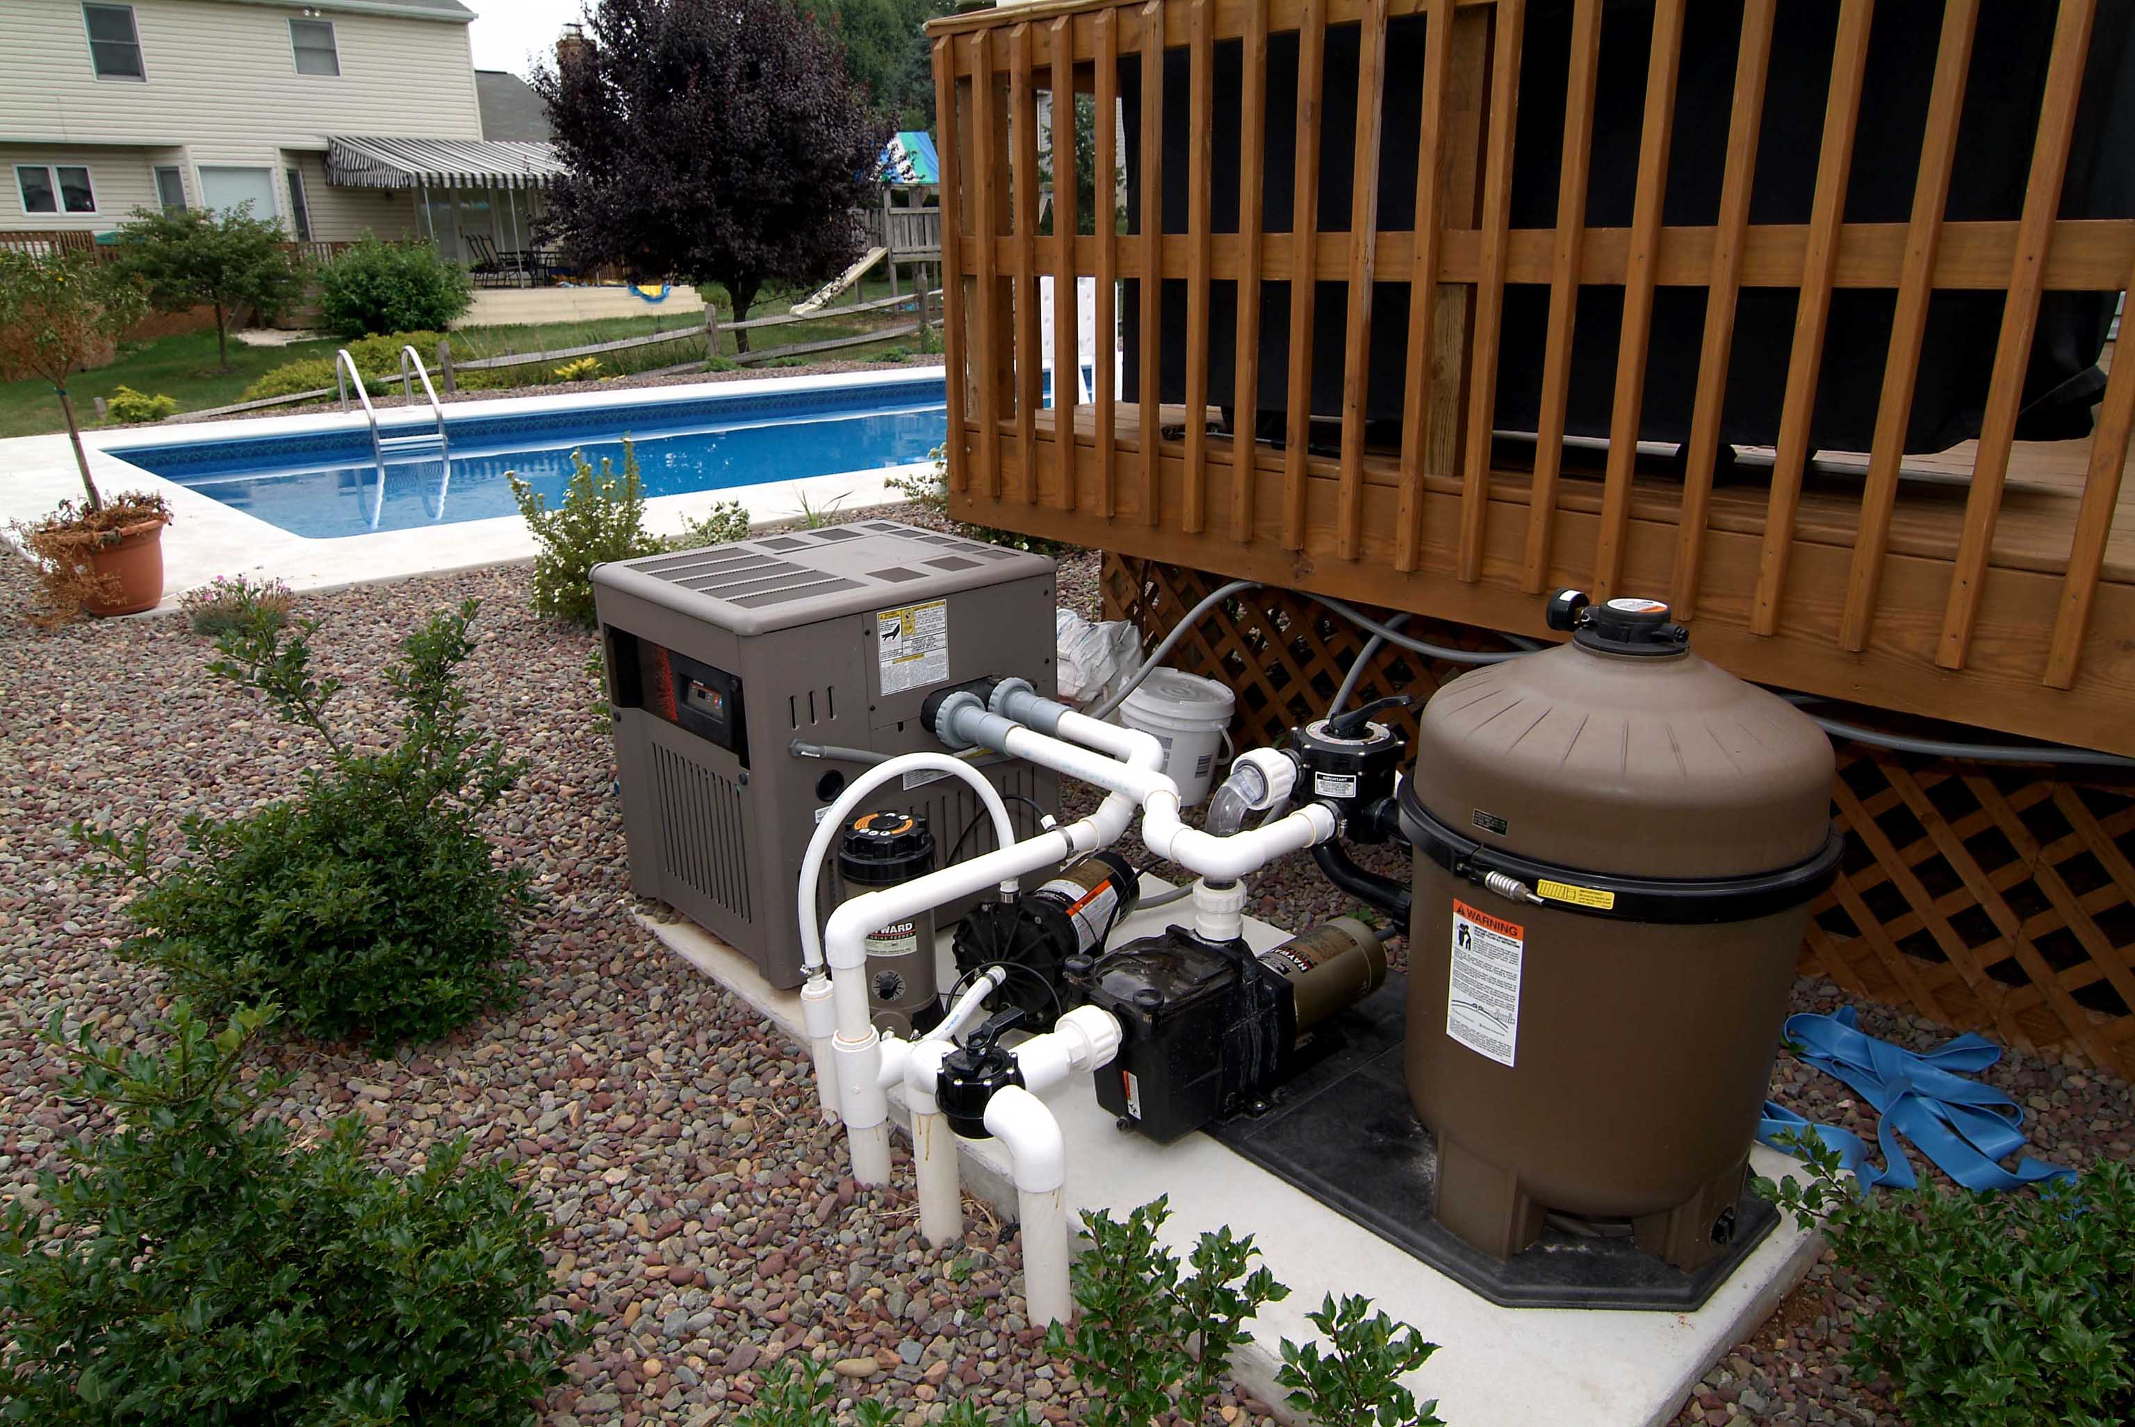
- Keep a thermometer in your pool. This will help you determine the perfect temperature for you and your family.
- Place your pool thermostat at the lowest setting that still maintains a comfortable swimming environment.
- Mark the "comfort setting" on the thermostat dial to avoid accidental or careless overheating.
- Lower your thermostat to 70 degrees when the pool will be unused for three or four days. For longer periods, turn the pool heater off.
- Guard your pool from the wind with a fence or hedge. A 7 mph wind at the surface of your pool can triple its heat loss.
- Use a pool cover when the pool is not in use. This can reduce its energy consumption by 50 to 75 percent.
- Tune up your pool heater annually. Properly tuned, it will operate more efficiently.
Residential Natural Gas Pool Heater Manufacturers
- Sta-Rite www.starite.com
- Lochinvar www.lochinvar.com
- Raypak www.raypak.com

Additional Residential Pool Heater Resources
- Energy Solutions Center www.energysolutionscenter.org
- R. L. Martin & Associates, Inc. www.rlmartin.com
- U.S. Department of Energy www.eere.energy.gov
For information on rebates and tax credits available for residential pool heaters, visit our website:

