Draft #2 – 11.23.09
s.vogt, vogt@hevanet.com

Boost your profits with energy efficiency

A Guide for Small Businesses

Small businesses increasingly feel the financial pinch from factors beyond their control: higher labor, goods and delivery costs; increased regulation; rising taxes and growing expectations from savvy customers. But one factor that is within your control is how you use energy.

By incorporating energy efficiency into your business you can cut energy costs by 25 percent or more – savings that can make a huge difference in your profit margin. Energy improvements also can enhance your business environment and improve your product or service, all at a lower cost.

This guide offers information on how your small business can reap the benefits of energy efficiency.

Energy wasted is profit lost

Small businesses often underestimate the value of energy cost savings to their bottom line. Acting on the premise that “time is money,” many businesses feel they can’t justify spending time on energy efficiency. However, not taking time to save energy can mean big money – lost. Consider the following information for four types of small businesses:

Food Service/Restaurant

Studies show that up to 80 percent of the energy bill for the commercial food service sector is spent on operations that perform no useful work.¹ These lost energy dollars are often wasted in the form of excess heat and noise generated by inefficient appliances, heating ventilation and air conditioning systems, lighting and refrigeration. In restaurants, the median annual bill for electricity and natural gas amounts to about $161 (USD) per restaurant seat. ² These energy expenses cut into slim profit margins that typically are only 3 to 9 percent of total revenue.³ Investing in energy efficiency can cut energy costs by 10 to 30 percent without sacrificing service, style or quality. ⁴

Lodging
Utility expenses represent the fastest-growing operating cost for hotels, increasing by an average of 12 percent per year from 2004 to 2006. ⁵

In the U.S., hotels and motels spend an average of $2,196 per available room each year on energy.⁶ Studies show that a 10 percent reduction in energy costs, which is easily achieved, is equivalent to increasing the average daily room rate by $0.83 (USD) for limited service hotels and $2.45 for full-service hotels.⁷ And energy-efficiency often results in better lighting and increased guest comfort, and it appeals to green-conscious travelers.

Retail
The cost of energy accounts for 3 to 8 percent of a retailer’s total operating expense. ⁸ In Canada, energy costs in retail range from $20/m² to $52/m². Through energy-efficient equipment and practices, even new facilities can save 20 percent or more, putting your business in a more price-competitive position. ⁹ Energy efficiency can improve customer and employee comfort and satisfaction and add to the aesthetic appeal of merchandise.

Offices
Energy represents between 19 and 30 percent of an office building’s costs. ¹¹ So, even a small percent of savings can add up to big money. Whether you own your building or are a tenant, you can take steps to cut energy use down to size. Studies show that energy-efficiency and other green building improvements can increase worker productivity, and that every $1 invested in energy measures is equal to an increase in property asset value of $2 to $3.¹²

Energy efficiency can benefit your business

- Reduces operations and maintenance expenses as well as capital costs
- Enhances employee comfort and productivity
- Protects from energy inflation
- Increases customer comfort and satisfaction, which could increase sales
- Increases asset value of your facility
- Demonstrates your commitment to sustainable business practices

How does your business use energy?
A key step to becoming more energy efficient is understanding how your business uses energy. How much energy you use and what you use it for varies with the type, size and location of your business. The charts below give you a general idea of how businesses like yours use energy and where to look for the greatest savings opportunities.

Your energy bills tell a story

You also can learn a lot by looking at a year’s worth of utility bills. Compare the peaks and valleys of energy use with factors such as seasonal weather and when you served the most customers. Look for patterns and anomalies. For example, if your retail business is busiest late in the calendar year, but your electricity use and demand charges are sky high in August, you might suspect that air conditioning contributes to high summer bills.

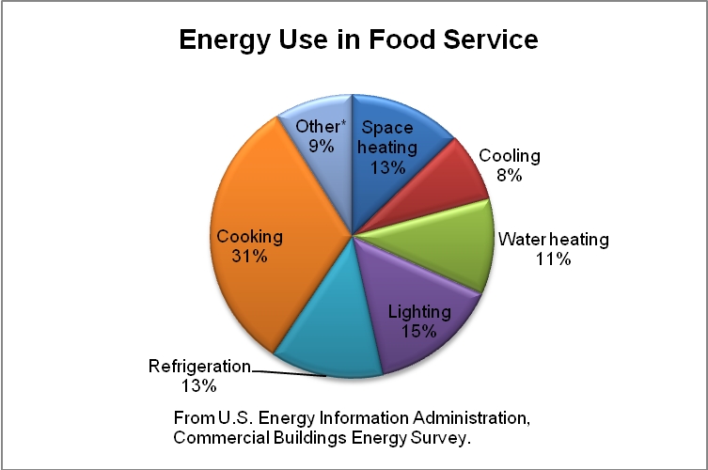

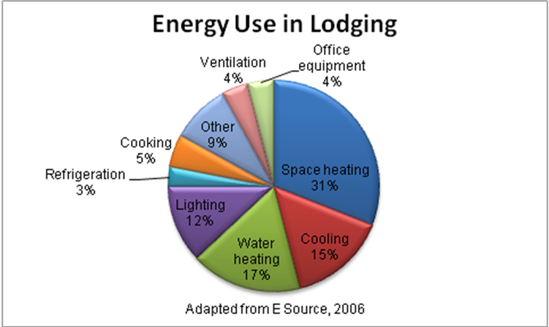

Are your demand charges too demanding?

It’s important to understand how you’re billed for energy. Natural gas utilities typically charge businesses for the amount of energy delivered, which is measured in cubic feet of natural gas.

Commercial electric bills often include two charges: demand and consumption. Consumption is the amount of electricity in kilowatt-hours (kWh) used during the billing period. The demand charge is for the peak amount of electricity in kilowatts (kW) that your business used within the billing period (or sometimes within the year). The electric utility charges this fee because it must have the electric capacity available when you need it (at your peak).

Demand charges can range from a few dollars to upwards of $20 per kW. You can save a lot by investing in upgrades that lower peak use of electricity.

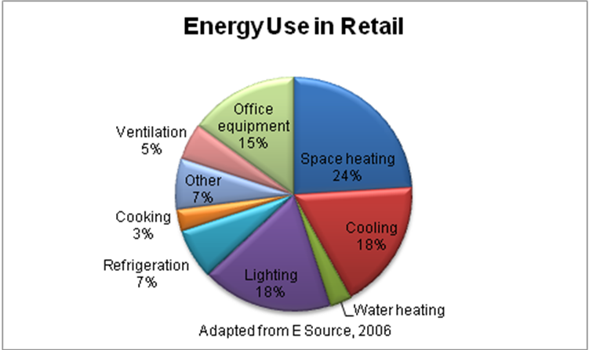

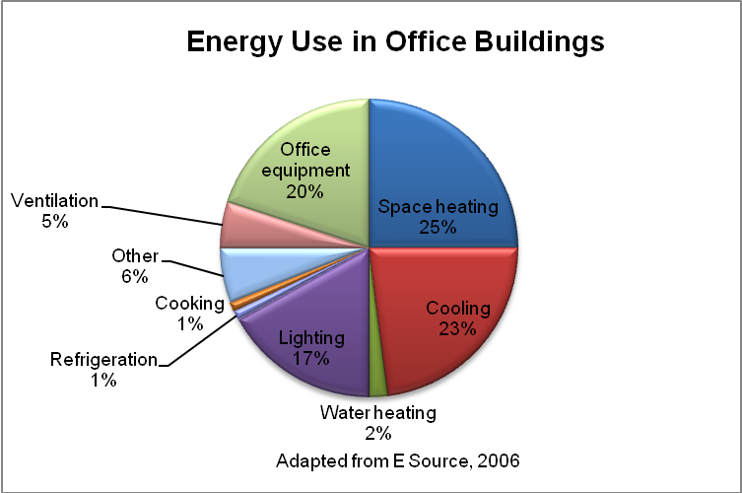

Energy-efficiency projects
Energy projects are categorized by energy-using system. However, improvements in one system can affect another. For example, lighting efficiency projects can lessen the load on your air conditioning system.

Lighting

If you haven’t made lighting improvements, talk with your lighting supplier about ENERGY STAR® labeled compact fluorescent light bulbs and exit signs, metal halide track or spot lights, T8 fluorescent lamps with electronic ballasts, LED lights and occupancy sensor controls.

Building Shell Improvements
Building shell upgrades decrease the load on your HVAC system, improve comfort and often reduce noise. Options include:
- Insulating your roof, walls, floor (or slab/foundation), ducts, pipes.
- Installing high performance windows, such as ENERGY STAR qualified models. New window technologies allow you to optimize for your climate and exposure (south, west, etc.) with special coatings that also reduce fading.
- Installing cool roofing and window tints or films in cooling-dominated climates.
Building shell projects can be a major investment. But over the life of the building, the operating savings in energy alone outweigh initial cost.

HVAC

Your HVAC system is critical to maintaining a comfortable, healthy and productive business environment and accounts for a large part of your energy expenses. Cooling systems, in particular, are often very energy intensive and almost always are fueled by electricity, with accompanying high demand charges The good news is that newer heating and cooling systems have advanced significantly in design, efficiency and affordability.

- When selecting new equipment, get quotes and specifications for standard- and high-efficiency units, and ask for a lifecycle cost analysis. Always hire an experienced contractor.
- New multi-zone gas heat pumps offer premium-efficiency heating and cooling, with efficiencies of 140 percent or more. (All heat pumps have efficiencies greater than 100 percent because they move heat, rather than create it.) Available in ducted and ductless models, these systems work for nearly all small businesses.
- Small businesses also can benefit from high-efficiency residential-sized natural gas condensing furnaces and residential- or small commercial-sized condensing boilers. These technologies have efficiencies of up to 98 percent.
- Consider high-efficiency gas-fired rooftop units. Several options are available, including those that modulate the burner and combustion air flows, use condensing heat exchangers or use pulse combustion. Efficiencies can reach 97 percent.
- For warehouses, garages and exterior patios, consider installing gas radiant heating, which warms people and objects rather than air.
- In humid environments, install gas desiccant dehumid-ification. This technology separately decreases humidity resulting in increased comfort, considerably less load on your cooling system and the opportunity for downsizing of equipment. New, smaller models make this technology available and reasonably priced for small businesses.
- For heat-generating processes such as cooking, explore heat recovery to capture waste heat.
- Install programmable thermostats. Install occupancy sensor thermostats in rooms that are used intermittently.

Tip: Compare efficiencies of heating systems or water heaters using the certification program sponsored by the Gas Appliance Manufacturers Association, Inc., now part of the Air-Conditioning, Heating, and Refrigeration Institute: www.ahrinet.org/Content/GAMAIBRCertification_581.aspx

Water Heating

Because water is constantly heated in the storage tank, standard water heaters waste energy even when no faucet is on. Newer, storage models can be 98 percent efficient and significantly reduce standby heat loss.

Businesses with low water use should consider a tankless water heater, which heats water only as it is used, or on demand. A tankless unit has a device that is activated by the flow of water when a hot water valve is opened. Natural gas tankless water heaters come in a variety of sizes for different applications.
Drain water heat recovery is an option that restaurants and businesses with laundries should consider. This technology uses wasted heat to preheat incoming water

Commercial Food Service Equipment

Food service equipment has seen big efficiency gains in recent years, with no sacrifice in food quality, food safety or time to table. When possible, buy ENERGY STAR models.

- If you’re in the market for a new dishwashing system, look into energy-efficient gas booster heaters. Compared to a standard electric booster heater, a gas booster heater could trim energy costs significantly due to the relative lower cost of natural gas as a fuel. Also, look for dishwashing systems that use one gallon or less of water per rack washed—typically, the less water required per rack, the less you’ll pay in energy costs.
- Fryers with the ENERGY STAR label are up to 25 percent more energy-efficient. With natural gas fryers, the added efficiency can save an average of $350 (USD) annually. ¹³
- ENERGY STAR qualified natural gas steam cookers can save you up to $820 (USD) per year and are 90 percent more water efficient. ¹⁴ The also offer shorter cook times, higher production rates and reduced heat loss due to better insulation and more efficient steam delivery.
- ENERGY STAR qualified gas convection ovens are 14 percent more efficient than standard models. ¹⁵
- ENERGY STAR labeled, thermostatically controlled, gas griddles can save an average of $170 (USD) annually on utility bills. ¹⁶

Office Equipment and Appliances
Always buy ENERGY STAR products for the greatest savings. ENERGY STAR labeled clothes washers have greater capacity and use less water.

Guide to High-Efficiency Natural Gas Equipment
Technology | Application | Options | How It Works | Efficiency/Savings | Other Benefits/ Comments
Gas heat pump | Heating & Cooling | 8 & 15-ton,  ducted & ductless | Collects/moves heat from outside air to inside during heating season; Reverses in cooling mode | Efficiencies up to 160%. Use 80% less electricity than traditional electric HVAC | Reduces noise, saves  Improves carbon footprint
Gas condensing furnace | Heating | Range of sizes from residential to small commercial | Advanced heat exchanger extracts more heat from flue gases | Efficiencies up to 98%. Use 33 -38% less energy than old models and 10% less energy than standard efficiency models | Even more savings with variable-speed, direct-drive electronically commutating motor for circulation fan
Gas condensing boiler | Heating | Range of sizes from residential up to 50 HP | Advanced heat exchanger extracts more heat from flue gases | Efficiencies up to 96%. Non-condensing models have efficiencies of 70-85%. Boilers > 20 years old operate at 60-70% | Space-saving small footprint
High-Efficiency gas-fired rooftop unit | Heating & Cooling | Range of sizes,  Modulating, or Condensing technology | Modulating units regulate combustion air and natural gas flows according to heating, demand, reducing cycling losses;  Condensing extracts more heat from flue gases | Efficiencies up to 97% | Greater temperature control & occupancy comfort. Easy installation
Desiccant dehumidification | Applied to cooling | Dry desiccant wheels | Dehumidifies ventilation air, reducing load on air conditioning system. Addresses cost &comfort issues caused by over-chilling to compensate for excess humidity | Save on air conditioning.  Higher efficiencies when used with energy-recovery ventilator | Greater comfort. Better indoor air quality. Reduces electric demand charges. Prevents moisture, mildew, microbes
High-efficiency gas tank water heater | Central | Standard high- efficiency  Condensing high-efficiency | Better insulation. Condensing units have advanced heat exchanger that extracts more heat from flue gases | Standard high-efficiency units save about 7%. Condensing units save up to30%
Gas tankless water heater | Point of use | Can be grouped together for larger applications | Avoids standby losses.  Heating device activated by water flow when hot water valve is opened | Saves 30% or more | Saves space due to no tank. Longer lasting. Avoid bacteria risks. Higher hot water output than electric models
ENERGY STAR qualified gas fryer | Food service | Open deep-fat models | Advanced burner and heat exchanger designs. Fry pot insulation reduces standby heat losses | Saves an average of $350 (USD)/year; 25 % more efficient than standard models | Shorter cook times. Higher production rates¹⁷
ENERGY STAR qualified gas steam cooker | Food service | 3-, 4-, 5-, and 6-pan sizes | Improved insulation. More efficient steam delivery system. Lower idle rates | Saves up to $820 (USD) /year compared to standard models | Shorter cook times. Higher production rates; 90% more water efficient
ENERGY STAR qualified gas convection oven | Food service | Full-size | Improved insulation. Lower idle rates | 14% more efficient than standard models
ENERGY STAR qualified, gas griddle | Food service | Single- and double-sided models | Thermostatically controlled. Lower idle rates | Saves an average of $170 (USD) annually compared to standard models | Equal or higher production rates

Identifying and prioritizing projects
Now that you know more about saving energy in your business, you may wonder: “What projects should I do first?” The answer is as individual as your business. Many companies start with projects that have the shortest payback—those that offer the greatest energy savings at the least cost.
Another factor to consider is whether you have equipment that is at the end of its useful life or that causes you reliability concerns. If so, replacing it with a more energy-efficient model makes sense especially if the incremental payback is reasonable.

You also should explore anything that is a comfort, aesthetic or productivity issue. For example, would new HVAC units improve comfort in your business and open opportunities for repeat customers?

The decision on where to begin often comes down to what is financially feasible for your business at a particular time and what grants, rebates, tax credits or other incentives are available for specific projects.

Understanding payback

- Simple payback is the amount of time it takes for the value of energy savings to equal the purchase price.

- Incremental payback tells you the length of time needed to pay for the difference between an efficient and less efficient unit, for example if you want to replace a piece of equipment anyway.

Financing energy-efficiency projects
Access to capital for energy-efficiency projects need not be an issue. Some upgrades require minimal funding. Often, businesses reinvest dollar savings from completed projects to help pay for future longer-payback improvements.
For upgrades that do require investment, take advantage of the variety of traditional and non-traditional financial resources that are available. (See resources to the right.)
A well-designed upgrade can provide your business a positive cash flow from energy savings while paying off the capital investment for new equipment.

Tip: Go high-performance for new buildings and renovations

If you are building a new facility or doing a major remodel, always include energy-efficient upgrades into your design due to the much lower incremental cost of "doing it right the first time." Compared with conventional buildings, high-performance buildings use significantly less energy, cost less to operate, are lighter and more comfortable and have a smaller environmental footprint. And energy-efficient design and construction does not need to cost any more than standard design.

Ideally, the process of designing, constructing or renovating a high-performance building follows a whole building design process. In this approach, the design team examines the integration of all building components and systems and determines how they best work together.

Hire an experienced design team and ask them to refer to the Advanced Energy Design Guide for Small Office Buildings (www.energycodes.gov/rc/AEDG_SmallOfficeBuildings.pdf)

Sources of additional information and funding
- Consortium for Energy Efficiency, www.cee1.org

- Gas Appliance Manufacturers Association, Inc. (GAMA), part of the Air-Conditioning, Heating, and Refrigeration Institute (AHRI)
www.ahrinet.org/Content/GAMAIBRCertification_581.aspx

- Database of State Incentives for Renewables and Effiiciency (U.S.), www.dsireusa.org

- U.S. Small Business Administration (SBA) loans, www.sba.gov/services/financialassistance/sbaloantopics/index.html

- ENERGY STAR® for Small Business, www.energystar.gov/index.cfm?c=small_business.sb_index

- U.S. Green Building Council, www.usgbc.org

- Canada Office of Energy Efficiency, Financial Assistance for Commercial and Institutional Organizations, oee.nrcan.gc.ca/commercial/financial-assistance/index.cfm?attr=20

- Database of Energy Efficiency Programs in Canada, oee.nrcan.gc.ca/corporate/statistics/neud/dpa/policy_e/programs.cfm?attr=20

- ecoENERGY Retrofit Grants and Incentives, oee.nrcan.gc.ca/corporate/retrofit-summary.cfm?attr=0

- The Canadian Green Building Council (CaGBC), LEED Canada, www.cagbc.org

¹ENERGY STAR® Web site, 11/21/09, www.energystar.gov/index.cfm?c=commercial_food_service.commercial_food_service

²E SOURCE, Delivering Energy and Energy Services to the Restaurant Sector,” http://files.harc.edu/Sites/GulfCoastCHP/Publications/DeliveringServicesResaurants.pdf

³Restaurant USA, “You’ve got the power to cut energy costs through conservation,” by Madeleine Burka, Aug. 2000, www.restaurant.org/rusa/magArticle.cfm?ArticleID=540

⁴ENERGY STAR, “Energy Use and Energy Efficiency Opportunities in Restaurants,” www.energystar.gov/ia/business/small_business/restaurant_factsheet.pdf

⁵ENERGY STAR Building Manual, Chapter 12, Hotels and Motels, www.energystar.gov/ia/business/EPA_BUM_CH12_HotelsMotels.pdf

⁶Ibid.

⁷ENERGY STAR Web site, 11/21/09, www.energystar.gov/index.cfm?c=hospitality.bus_hospitality

⁸www.epa.gov/RDEE/documents/sector-meeting/4biv_retail.pdf

⁹Natural Resources Canada Web site, 11/20/09, http://oee.nrcan.gc.ca/publications/commercial/m144-23-2003e1.cfm?attr=20

¹⁰ Natural Resources Canada Web site, 11/20/09, http://oee.nrcan.gc.ca/publications/commercial/m144-23-2003e3.cfm?attr=20

¹¹E SOURCE, “Managing energy costs in office buildings,” 2006, www.esource.com/BEA/demo/PDF/CEA_offices.pdf

¹²ENERGY STAR, “The Power to protect the environment through energy efficiency,” www.energystar.gov/ia/partners/downloads/energy_star_report_aug_2003.pdf

¹³ENERGY STAR, “Putting energy into profits: ENERGY STAR Guide for restaurants,” www.energystar.gov/ia/business/small_business/restaurants_guide.pdf

¹⁴ENERGY STAR Web site, 11/21/09, www.energystar.gov/index.cfm?c=steamcookers.pr_steamcookers

¹⁵ENERGY STAR Web site, 11/21/09, www.energystar.gov/index.cfm?c=ovens.pr_comm_ovens

¹⁶ENERGY STAR Web site, 11/21/09, www.energystar.gov/index.cfm?c=griddles.pr_comm_griddles

¹⁷EENERGY STAR Web site, 11/21/09, www.energystar.gov/index.cfm?c=fryers.pr_fryers

